Lab 2

PWM and LED dimmer  
Cory Cook  
Garrett Albers

Contents

Introduction 1

Design 1

Main 1

Lab2.v 2

Pulse Width Modulation 2

pwm_counter.v 2

Seven Segment Display Driver 2

disp_hex_mux.v 3

Tests 4

Lab 2 Test 4

PWM Test 4

Conclusion 4

# Introduction

Pulse width modulation (PWM) is a technique for controlling the switching frequency of a device. The duty cycle associated with the PWM controls the percent “ON” time of the device. The resolution of the PWM is the number of unique duty cycles available. For instance, four-bit resolution of a binary PWM would represent 2^4 = 16 steps between zero and one-hundred percent.

It is possible to control the perceived brightness of a light by controlling the percent “ON” time of the light using PWM.

# Design

## Main

The main module of the application will reference the inputs from the board including the first four switches, the clock, and the reset button. It will also reference the outputs which are the seven segment displays and the seven segment enable output.

The main module will instantiate an instance of the pulse width modulation module passing the clock and switches as inputs. The switches will be mapped to the duty cycle (count_amount) of the PWM, the clock to the clock (clk_input). The output of the pwm (counter_output) will be mapped to a local wire and passed to the display driver.

The main module will instantiate an instance of the display driver module passing the clock, reset, switches, and a constant four bits binary valued at fifteen. The clock (clk) maps to the clock (clk), the reset (reset) maps to the reset (reset), the switches (sw) map to all of the hex inputs (hex0:hex3), the constant (4’b1111) maps to the decimal point input (dp_in). The output of the display driver (an, sseg) is mapped directly to the corresponding ports on the device.

### Lab2.v

module lab2(input [3:0] sw, input clk, input reset, output [7:0] sseg, output [3:0] an);

wire pwm_on;

pwm pwm_counter(.clk_input(clk), .count_amount(sw), .counter_output(pwm_on));

disp_hex_mux display_hex(.clk(clk), .reset(reset), .hex3(sw), .hex2(sw), .hex1(sw),

.hex0(sw), .pwm_on(pwm_on), .dp_in(4’b1111), .an(an), .sseg(sseg));

endmodule

## Pulse Width Modulation

The pulse width modulation module can be instantiated with different sizes. The size corresponds to the resolution of the pulse width. The size directly affects the bit width of the duty cycle (count_amount) input.

The PWM accepts a clock (clk_input) and a duty cycle (count_amount) as input and outputs a one bit output indicating the state of the pwm.

The PWM module is a Moore-style state device with current state (current_count) and a next state (next_count). The next state is one plus the current state. The current state is set to the value of the next state at the positive edge trigger of the clock. The output (counter_output) is assigned a bit value indicating whether the current state is less than or equal to the duty cycle.

### pwm_counter.v

module pwm #(parameter SIZE=4)

(input clk_input, input[SIZE-1:0] count_amount, output wire counter_output);

reg [SIZE-1:0] current_count = 0;

wire [SIZE-1:0] next_count;

assign counter_output = current_count <= count_amount;

assign next_count = current_count + 1;

always @(posedge clk_input) current_count <= next_count;

endmodule

## Seven Segment Display Driver

The seven segment display driver accepts a clock (clk), a reset, a pwm state (pwm_on), four hex values (hex0:hex3), and a four-bit decimal point indicator. The driver outputs a seven segment display code (sseg) and a seven segment enable code (an) indicating which display is active.

The local parameter N is assigned to set a static timer that selects when a particular display is active.

The driver uses two Moore-style state machines: one drives the counter that determines the timing and the other determines the currently selected hex and decimal point values.

For this example the last three seven segment displays are disabled so they forced high for their enable bits.

The driver outputs the active enable bits and the static display code for the currently active hex value.

The code used in the design is the code from the book. The code below is a condensed version of the code from the book.

### disp_hex_mux.v

module disp_hex_mux(input clk, reset, pwm_on

input [3:0] hex3, hex2, hex1, hex0, dp_in,

output [3:0] an, output reg [7:0] sseg);

localparam N=18;

wire [N-1:0] q_next;

wire [3:0] hex_in, hex_group [0:3];

wire [1:0] sel_next;

wire dp;

reg [N-1:0] q_reg = 0;

reg [1:0] sel = 0;

assign hex_group[0] = hex0;

assign hex_group[1] = hex1;

assign hex_group[2] = hex2;

assign hex_group[3] = hex3;

assign hex_in = hex_group[sel];

assign dp = dp_in[sel];

assign sel_next = sel + 1;

assign q_next = q_reg + 1;

assign an[3] = q_reg[N-1] & q_reg[N-2] & pwm_on | 1; // disabled

assign an[2] = q_reg[N-1] & ~q_reg[N-2] & pwm_on | 1; // disabled

assign an[1] = ~q_reg[N-1] & q_reg[N-2] & pwm_on | 1; // disabled

assign an[0] = ~q_reg[N-1] & ~q_reg[N-2] & pwm_on;

always @(posedge clk, posedge reset) begin

q_reg <= reset ? 0 : q_next;

sel <= reset ? 0 : sel_next;

end

always @* begin

case(hex_in)

4’h0: sseg[6:0] = 7’b0000001;

4’h1: sseg[6:0] = 7’b1001111;

4’h2: sseg[6:0] = 7’b0010010;

4’h3: sseg[6:0] = 7’b0000110;

4’h4: sseg[6:0] = 7’b1001100;

4’h5: sseg[6:0] = 7’b0100100;

4’h6: sseg[6:0] = 7’b0100000;

4’h7: sseg[6:0] = 7’b0001111;

4’h8: sseg[6:0] = 7’b0000000;

4’h9: sseg[6:0] = 7’b0000100;

4’ha: sseg[6:0] = 7’b0001000;

4’hb: sseg[6:0] = 7’b1100000;

4’hc: sseg[6:0] = 7’b0110001;

4’hd: sseg[6:0] = 7’b1000010;

4’he: sseg[6:0] = 7’b0110000;

default: sseg[6:0] = 7’b01110000;

endcase

sseg[7] = dp;

end

endmodule

# Tests

## Lab 2 Test

Figure 1 shows the test results of the main module. The clock (clk) alternates every two nanoseconds. The enable and disable time is determined by the PWM using the switches (sw) value as the duty cycle. The output value (sseg) is the display code corresponding with the switches value. In the test bench the switch value increments every fifty cycles. The cycle parameter is specific to the test bench.

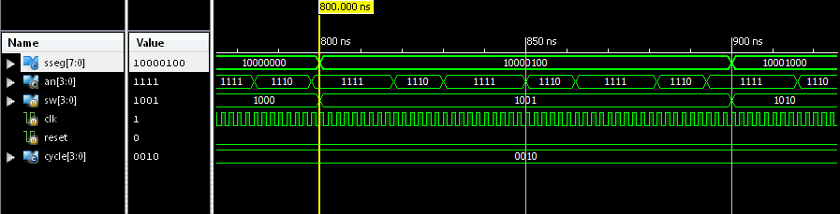

Figure 1: Lab2.v test

## PWM Test

Figure 2 shows the test results for the PWM. The duty cycle (count_amount) increases once every 32 clock cycles. The clock cycle is set to two nanoseconds for the purposes of this test bench.

You can see that as the duty cycle increases, the active time for the pwm output (counter_output) increases.

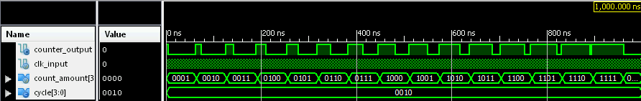

Figure 2: pwm.v test

# Conclusion

Pulse width modulation allows for controlled power output from digital logic control. Then technique can be utilized in cases where a physical device needs to be controlled by a digital circuit. Knowing how PWM is implemented will allow us to recreate or properly use this technology in the future.